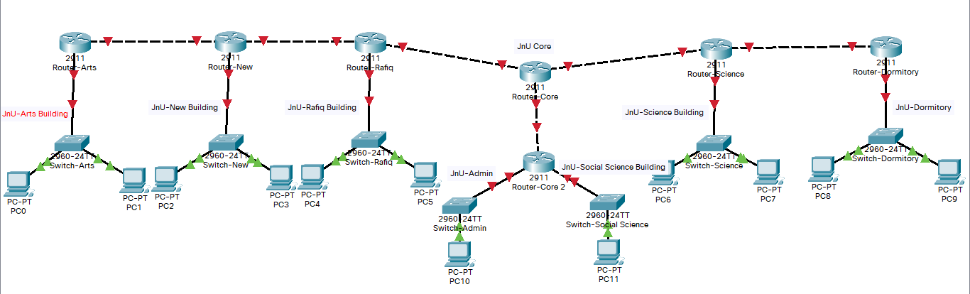

BTCL has granted Jagannath University a block of addresses starting with **1YX.XY.0.0/20**. Jagannath Univeristy wants to distribute these blocks to different academic and administrative buildings as follows:

1. Arts Building: 300 addresses
2. New Building: 500 addresses
3. Rafiq Building: 200 addresses
4. Admin Building: 250 addresses
5. Social Science Building: 350 addresses
6. Science Building: 600 addresses
7. Dormitory Building: 200 addresses

Design the subblocks and give the slash notation for each subblock. All the point-to-point connections address should be allocated from this granted block. Find out how many addresses are still available after these allocations.

Implement the network topology in packet tracer and test data transmission among different networks using **RIPv2 routing protocol**.

Site Address: 1YX.XY.0.0/20 [XY represents last two digits of your student ID]

Global configuration mode:

Router rip

Version 2

Network 200.20.20.0

Network 120.20.30.0

Exit